**PALO-ALTO Snapshot Creation Error:**

**Error Message:**

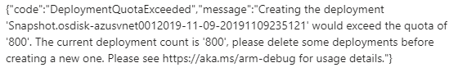

**Troubleshooting Steps:**

**From Portal:**

<https://portal.azure.com/> -> Open Resource Groups -> Open the Resource (myResourceGroupName) -> Click on Deployments -> Select one of the deployments and click on Delete -> Click on Yes to proceed with deletion.

1. Login to the portal, Select Subscriptions.

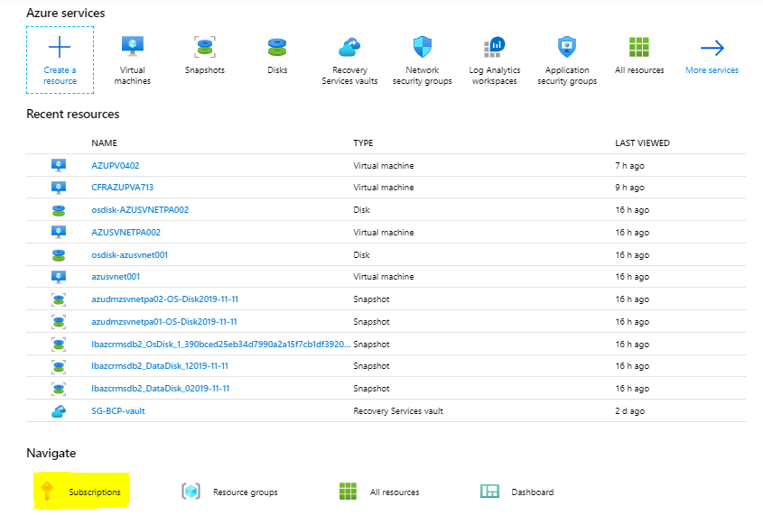

1. Select the **France APL/CMA-CGM Azure DC Subscription.**

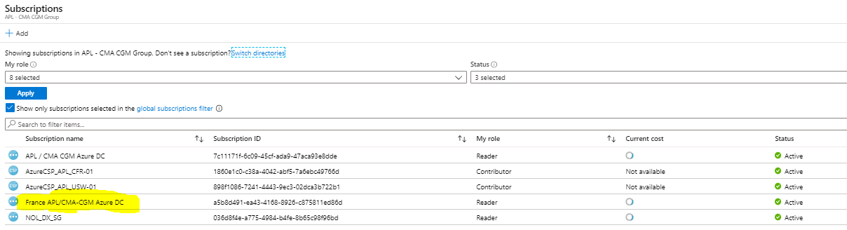

1. Select below highlighted resource group [**RG-CFR-INFRA-NETWORK-01**](https://portal.azure.com/#@nol.onmicrosoft.com/resource/subscriptions/a5b8d491-ea43-4168-8926-c875811ed86d/resourceGroups/RG-CFR-INFRA-NETWORK-01).

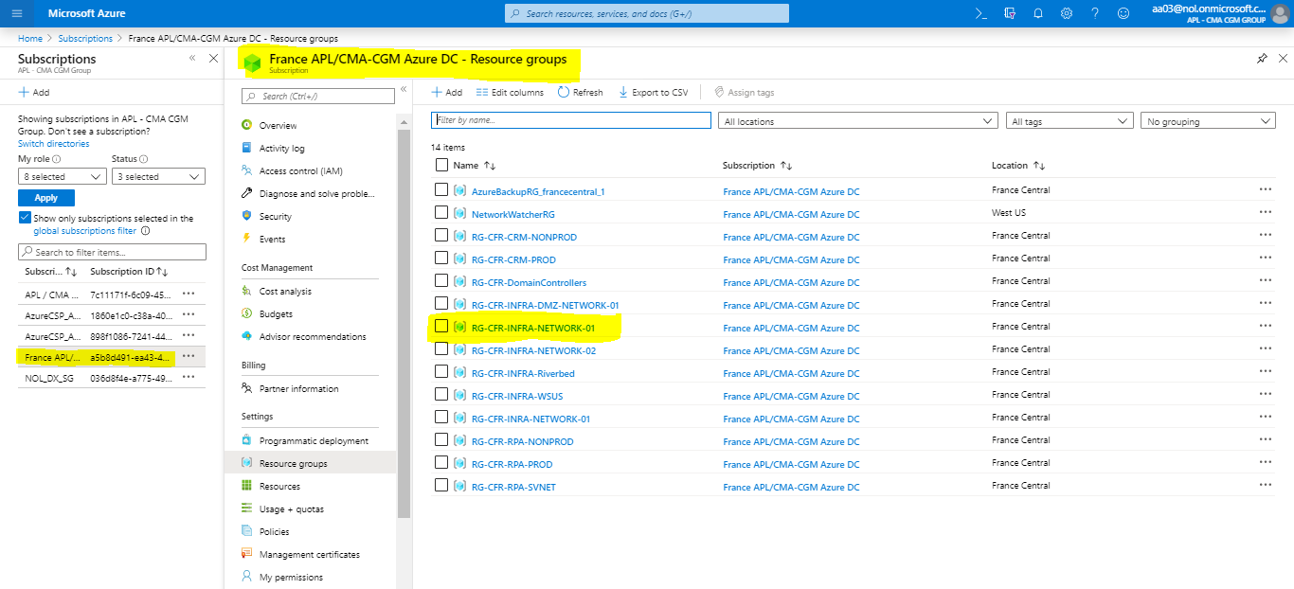

1. In Selected Resource Group got to Deployments option, As shown in below image.

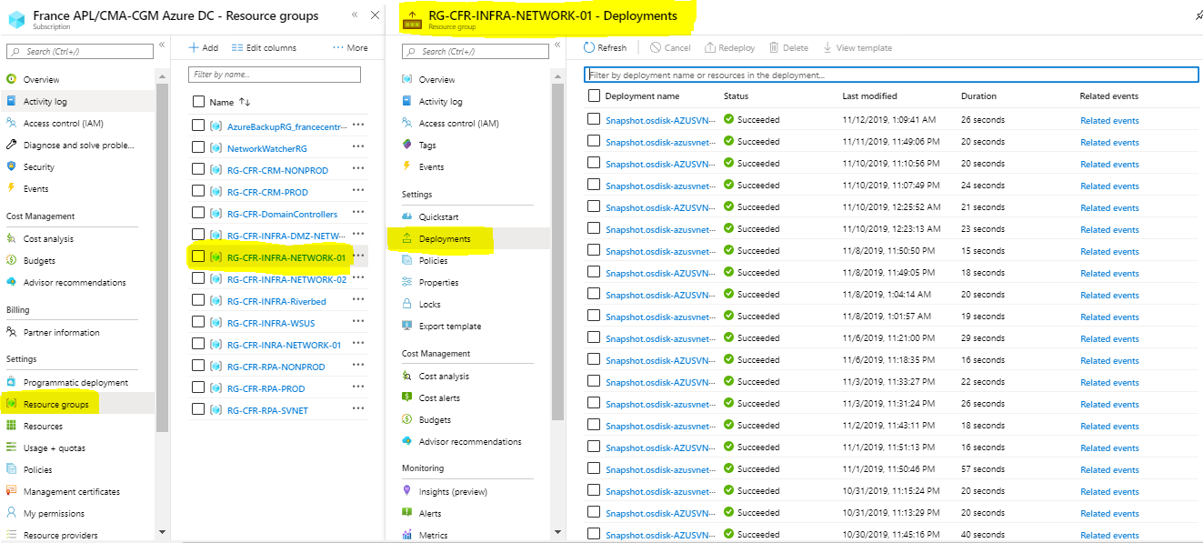

1. In this Deployments Delete the Oldest Snapshots as per your requirement.

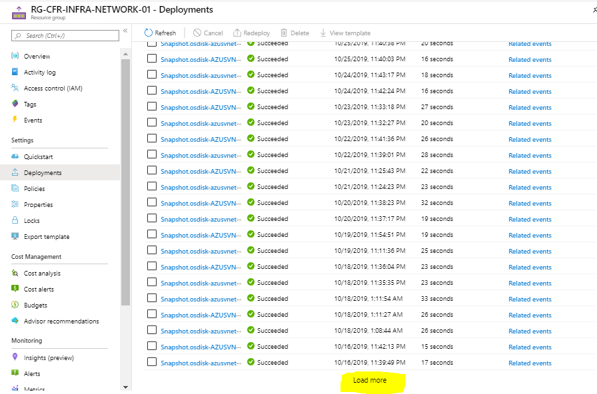

For check the old Snapshot and delete load more,

**Refer the below Link for your reference:**

<https://vijredblog.wordpress.com/2016/12/29/creating-the-deployment-would-exceed-the-quota-of-800-azure-error-resolution/>